Pressure Transducer

Triton Rocket Club

*Avionics*

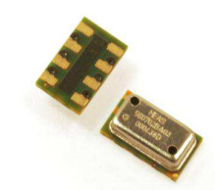

Table of Contents

1.1 Introduction 3

1.2 System Architecture 3

1.2.1 High-Level System Overview 3

1.2.2 Component Overview 4

1.2.3 Functional Circuit 4

1.2.4 Pin Configuration 5

1.3 Component Requirements 5

1.4 Component Specifications 5

1.5 PCB Design 5

1.5.1 Device Dimensions 6

1.5.2 Pad Layout 6

1.5.3 EagleCAD Package and Schematic 7

1.6 Pressure Sensing Functionality 7

1.7 Pressure and Temperature Calculation 8

1.7.1 Second Order Temperature Compensation 9

1.8 Interfacing via I2C Protocol 9

1.8.1 I2C Commands 9

1.8.2 Start and Stop Conditions 10

1.8.3 Reset Sequence 10

1.8.4 PROM Read Sequence 10

1.8.5 Conversion Sequence 11

1.8.6 Cyclic Redundancy Check (CRC) 11

## Introduction

This document covers all the information regarding the MS5611-01BA03 pressure transducer and its applicability to the avionics bay of our current rocket build: **Intrepid**. ­The main functionality of the MS5611 is to perform as a secondary altimeter being primarily referenced while Intrepid is in within the Earth’s atmosphere. Its data would eventually be transmitted as part of our telemtry package being delivered to our ground control station.

## System Architecture

## 1.2.1 High-Level System Overview

Figure 1: Avionics Bay System Overview

## 1.2.2 Component Overview

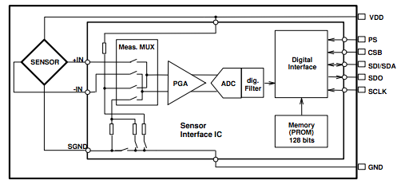

Figure 2: Block diagram of MS5611

## 1.2.3 Functional Circuit

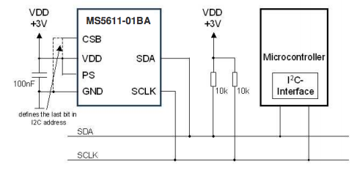

Figure 3: MS5611 Functional Circuit

## 1.2.4 Pin Configuration

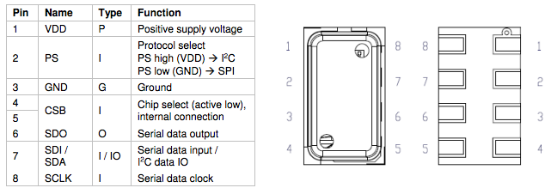

Figure 4: MS5611 Pin Configuration

## 1.3 Component Requirements

* High accuracy absolute low pressure sensing on order of ~ 0.2 psia
* Temperature compensation
* IC breakout board available for prototyping/testing
* Termination style compatible with PCB (ideally SMD)
* Digital output able to be read by microcontroller (ideally I2C)
* Cost: < $20
* Power efficient: < ten mA

## 1.4 Component Specifications

* Operating pressure range: 0.15 ~ 17.4 PSIA with accuracy of +/- 0.022 PSIA
* Temperature compensated – Operating Temp range: -40 ~ 85 C
* IC breakout board available <https://drotek.com/shop/en/home/44-ms5611-pressure-barometric-board.html>
* SMD – 8 solder pad pins available for PCB implementation
* Both I2C and SPI protocol available
* Cost $ 14.14
* Current draw ~ 1 uA

## 1.5 PCB Design

The overall goal of the Avionics team is to place all of the necessary electronics into a main PCB. In order to integrate the MS5611 into this board, a CAD device file comprised of both a package (footprint) and a circuit schematic is required.

## 1.5.1 Device Dimensions

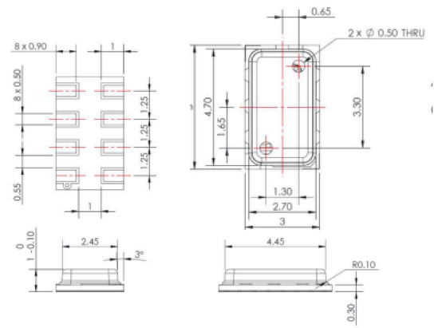

Figure 5: Device dimensions in MM

## 1.5.2 Pad Layout

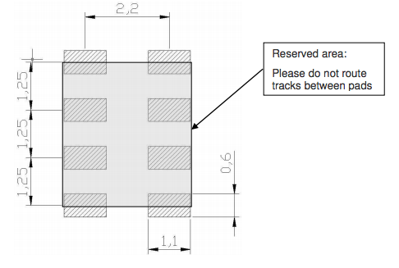

Figure 6: Pad Layout in MM

## 1.5.3 EagleCAD Package and Schematic

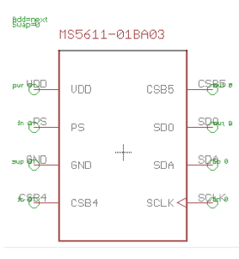 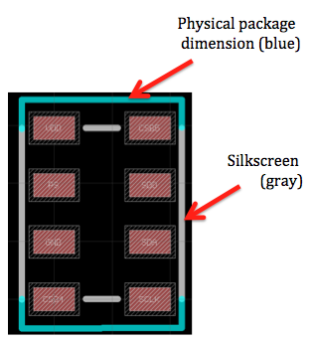

Figure 7: EagleCAD Schematic Figure 8: EagleCAD Footprint

## 1.6 Pressure Sensing Functionality

The MS5611-01BA consists of a piezo-resistive sensor and a sensor interface IC. A piezo-resistive sensor is a strain gauge changes its electrical resistance proportional physical distortions under loading and applied strains, in this case, pressure. The main function of the MS5611 is to convert the uncompensated analogue output voltage from the piezo-resistive pressure sensor to a 24-bit digital value, as well as providing a 24-bit digital value for the temperature of the sensor.



## 1.7 Pressure and Temperature Calculation

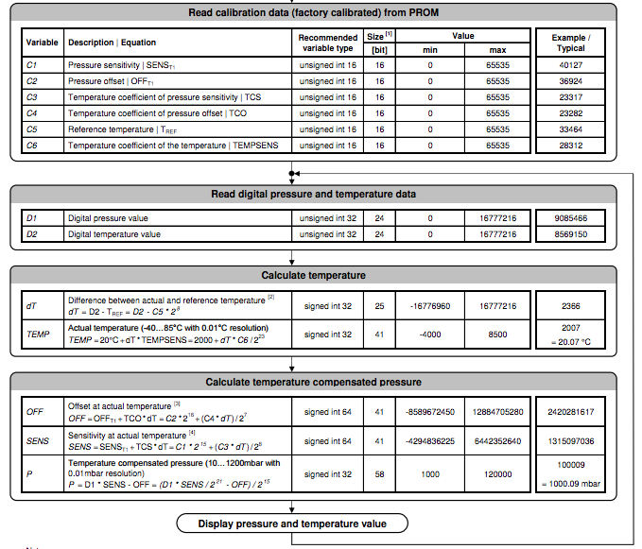

Figure 9: Pressure and Temperature Calculation Flowchart

Notes:

1. Maximal size of intermediate result during evaluation of variable

2. Min and Max have to be defined

3. Min and Max have to be defined

4. Min and Max have to be defined

## 1.7.1 Second Order Temperature Compensation

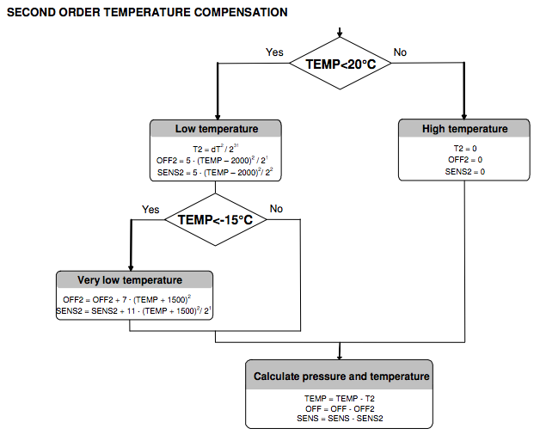

Figure 10: Second Order Temperature Compensation Flowchart

## 1.8 Interfacing via I2C Protocol

The external microcontroller clocks in the data through the input SCLK (Serial CLocK) and SDA (Serial DAta). The sensor responds on the same pin SDA which is bidirectional for the I2C bus interface. So this interface type uses only 2 signal lines and does not require a chip select, which can be favorable to reduce board space. In I2C-Mode the complement of the pin CSB (Chip Select) represents the LSB of the I2C address. It is possible to use two sensors with two different addresses on the I2C bus. The pin CSB shall be connected to VDD or GND (do not leave unconnected!).

## 1.8.1 I2C Commands

The MS5611-01BA has only five basic commands:

1. Reset

2. Read PROM (128 bit of calibration words)

3. D1 conversion

4. D2 conversion

5. Read ADC result (24 bit pressure / temperature)

## 1.8.2 Start and Stop Conditions

Each I2C communication message starts with the start condition and it is ended with the stop condition. The MS5611-01BA address is 111011Cx, where C is the complementary value of the pin CSB. Since the IC does not have a microcontroller inside, the commands for I2C and SPI are quite similar.

## 1.8.3 Reset Sequence

The reset can be sent at any time. In the event that there is not a successful power on reset this may be caused by the SDA being blocked by the module in the acknowledge state. The only way to get the MS5611-01BA to function is to send several SCLKs followed by a reset sequence or to repeat power on reset.

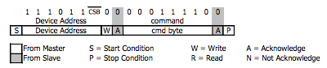

Figure 11: I2C Reset Command

## 1.8.4 PROM Read Sequence

The PROM Read command consists of two parts. First command sets up the system into PROM read mode. The second part gets the data from the system.

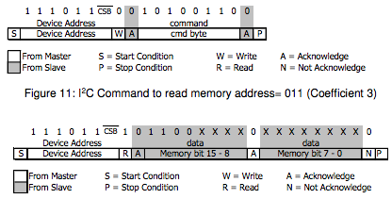

Figure 12: I2C Answer from MS5611

## 1.8.5 Conversion Sequence

A conversion can be started by sending the command to MS5611-01BA. When command is sent to the system it stays busy until conversion is done. When conversion is finished the data can be accessed by sending a Read command, when an acknowledgement appears from the MS5611-01BA, 24 SCLK cycles may be sent to receive all result bits. Every 8 bit the system waits for an acknowledge signal.

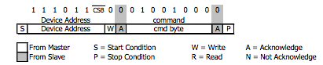

Figure 13: I2C Command to Initiate a Pressure Conversion

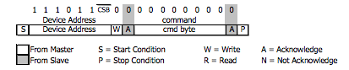

Figure 14: I2C ADC Read Sequence

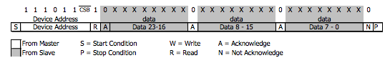

Figure 15: I2C Answer from MS5611

## 1.8.6 Cyclic Redundancy Check (CRC)

MS5611-01BA contains a PROM memory with 128-Bit. A 4-bit CRC has been implemented to check the data validity in memory. The application note AN520 describes in detail CRC-4 code used.

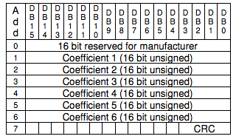

Figure 16: Memory PROM Mapping

## 1.9 Implementation Procedure

In progress